🔷 What is a UML Diagram?
✅ Definition
UML (Unified Modeling Language) is a standard visual language used to design, visualize, document, and communicate the structure and behavior of a software system before writing actual code.
👉 UML is language-independent (used for Java, C#, Python, etc.).

🎯 Why UML Diagrams Are Used?
Purpose | Explanation
Visual Understanding | Easy to understand complex systems
Design Before Coding | Catch design issues early
Team Communication | Developers, testers, architects align
Documentation | Acts as system blueprint
Maintenance | Helps future developers

🧠 Real-World Analogy
UML is like a building blueprint
You don’t start construction without drawings — similarly, you don’t build software without UML.

🔷 Types of UML Diagrams
UML diagrams are divided into two main categories:

1️⃣ Structural Diagrams (How the system is built)
Diagram | Purpose
Class Diagram | Structure of classes
Object Diagram | Object instances
Component Diagram | Software components
Deployment Diagram | Hardware + software
Package Diagram | Grouping of elements

2️⃣ Behavioral Diagrams (How the system behaves)
Diagram | Purpose
Use Case Diagram | User interaction
Sequence Diagram | Message flow
Activity Diagram | Workflow
State Diagram | State transitions

🔷 UML Diagram Types – Explained with Examples

🔹 1. Class Diagram (Most Important for Java)
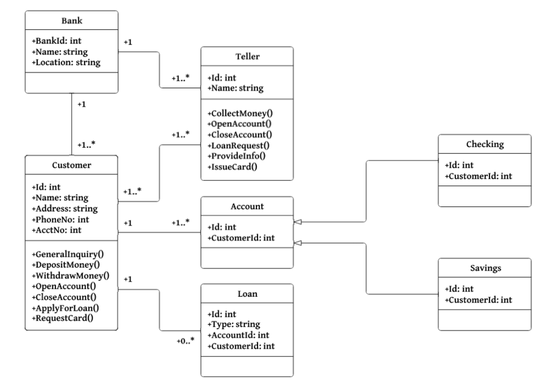
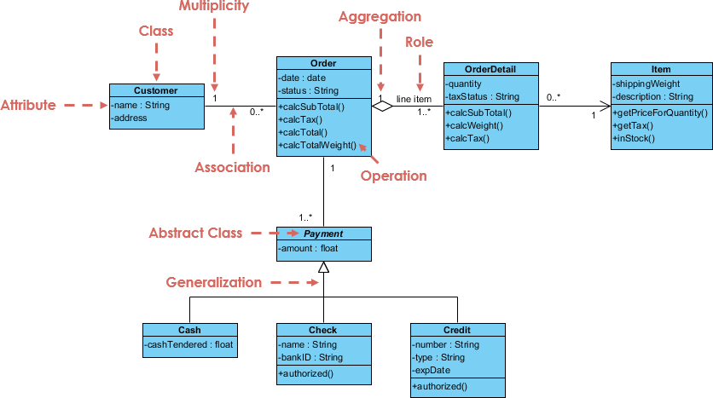
✅ Purpose
Shows:
- Classes
- Attributes
- Methods
- Relationships (inheritance, association, etc.)

🧱 Class Diagram Structure
---------------------
| Employee |
---------------------
| - id : int |
| - name : String |
---------------------
| + getName() |
| + setName() |
---------------------

🎯 Uses
- Object-oriented design
- Java class creation
- Understanding relationships
1️⃣ Classes & Their Responsibilities
🔹 Customer
- Attributes
  - name : String
  - address
- Meaning: Represents a customer who places orders.

🔹 Order
- Attributes
  - date : date
  - status : String
- Operations
  - calcSubTotal()
  - calcTax()
  - calcTotal()
  - calcTotalWeight()
- Meaning: Represents a customer order and contains business logic for price and tax calculation.

🔹 OrderDetail (Line Item)
- Attributes
  - quantity
  - taxStatus : String
- Operations
  - calcSubTotal()
  - calcTax()
- Meaning: Represents individual items inside an order (quantity + tax logic).

🔹 Item
- Attributes
  - shippingWeight
  - description : String
- Operations
  - getPriceForQuantity()
  - getTax()
  - inStock()
- Meaning: Represents a product that can be ordered.

🔹 Payment (Abstract Class)
- Attributes
  - amount : float
- Meaning: Base class for all payment types. Cannot be instantiated directly.

🔹 Cash, Check, Credit (Concrete Classes)
They inherit from Payment.
- Cash
  - cashTendered : float
- Check
  - name : String
  - bankID : String
  - authorized()
- Credit
  - number : String
  - type : String
  - expDate
  - authorized()

2️⃣ Relationships Explained
🔗 Association (Customer ↔ Order)
- Multiplicity
  - Customer → Order: 1
  - Order → Customer: 0..*
- Meaning:
  - One customer can place many orders
  - Each order belongs to exactly one customer

◇ Aggregation (Order ◇── OrderDetail)
- Shown using a hollow diamond
- Multiplicity
  - Order → OrderDetail: 1..*
- Meaning:
  - An order contains one or more line items
  - OrderDetail can exist independently of Order (weak “has-a” relationship)

🔗 Association (OrderDetail ↔ Item)
- Multiplicity
  - OrderDetail → Item: 1
  - Item → OrderDetail: 0..*
- Meaning:
  - Each line item refers to one item
  - An item can appear in many order details

🔗 Association (Order ↔ Payment)
- Multiplicity
  - Order → Payment: 1..*
- Meaning:
  - One order can have multiple payments
  - Example: part cash + part credit

🔺 Generalization / Inheritance
- Payment ⬆ Cash, Check, Credit
- Meaning:
  - All payment types share common behavior (amount)
  - Each subclass adds its own details
- Why it’s used:
  - Polymorphism
  - Clean extensibility (add UPI, Wallet, etc.)

3️⃣ UML Concepts Highlighted in the Diagram
UML Concept | Example in Diagram | Meaning
Class | Customer, Order | Blueprint of objects
Attribute | name : String | Data members
Operation | calcTotal() | Methods
Association | Customer–Order | Relationship
Aggregation | Order–OrderDetail | Weak has-a
Multiplicity | 1, 0..*, 1..* | Quantity rules
Abstract Class | Payment | Cannot instantiate
Inheritance | Cash → Payment | IS-A relationship

4️⃣ Real-World Flow (Easy to Remember 🧠)
- Customer places an Order
- Order contains multiple OrderDetails
- Each OrderDetail refers to an Item
- Order is paid using one or more Payments
- Payment can be Cash / Check / Credit

🔹 2. Use Case Diagram
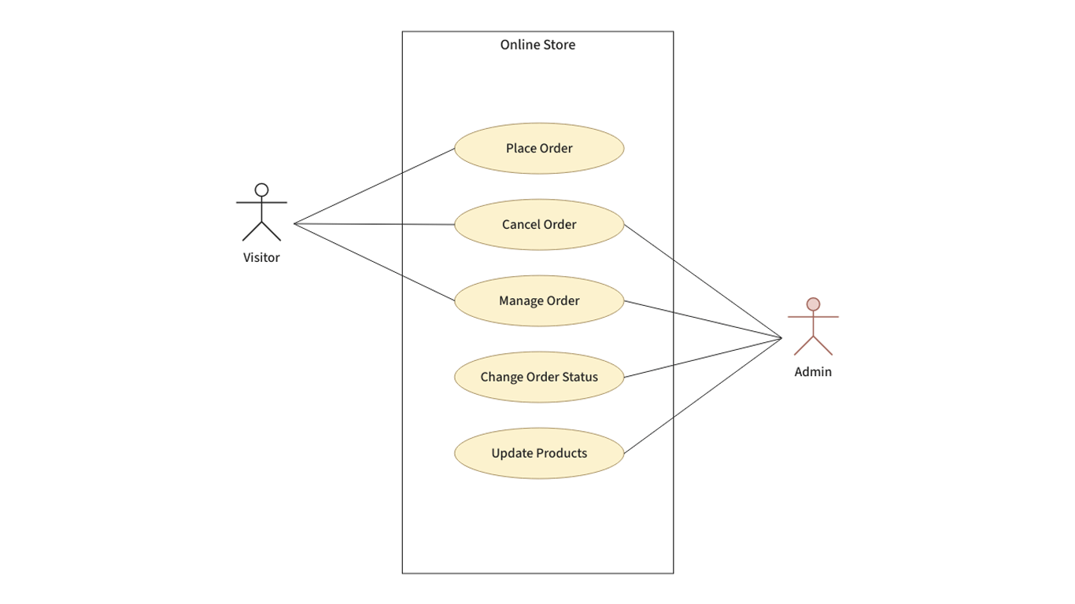

✅ Purpose
Shows what the system does, not how.

📌 Example
Actors:
- User
- Admin
Use cases:
- Login
- Register
- View Profile

🎯 Uses
- Requirement analysis
- Client communication
- Feature planning

🔹 3. Sequence Diagram
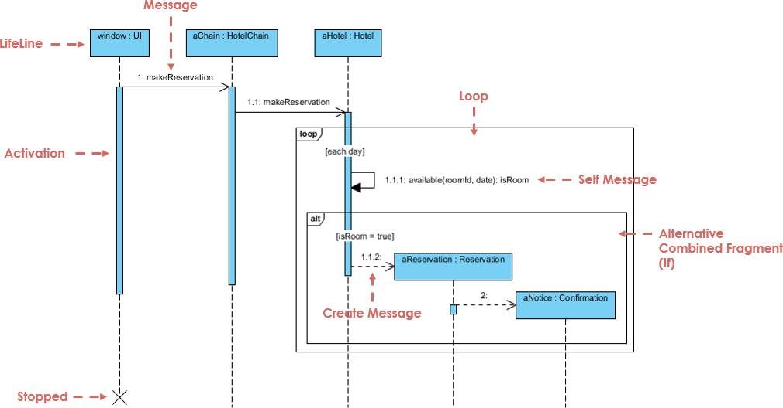

✅ Purpose
Shows interaction order between objects over time.

📌 Example Flow
- User → Login Page
- Login Page → Auth Service
- Auth Service → Database
- Response sent back

🎯 Uses
- Method call flow
- API interaction
- Debugging logic

🔹 4. Activity Diagram
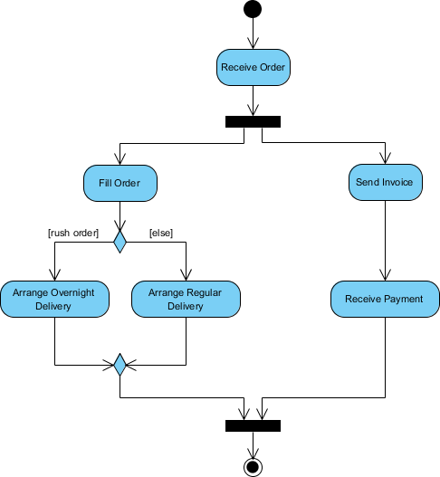
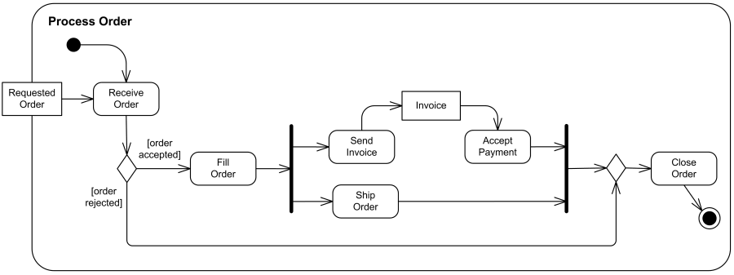
✅ Purpose
Represents workflow or business process

📌 Example
Start → Enter Details → Validate → Payment → Success → End

🎯 Uses
- Business logic
- Process automation
- Decision flows

🔹 5. State Diagram
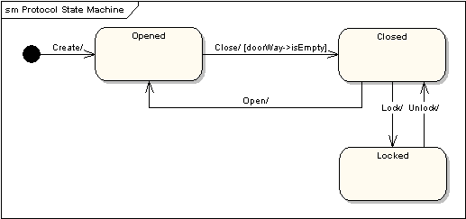
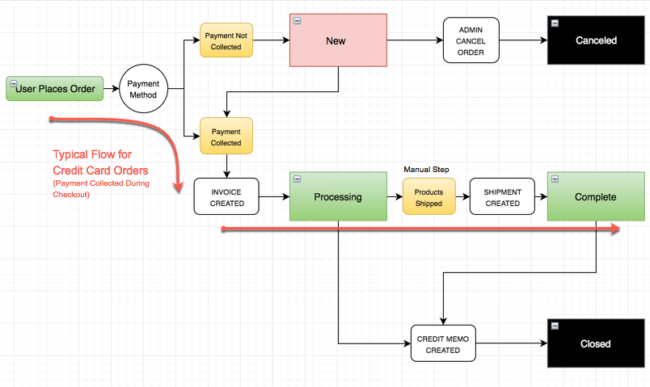
✅ Purpose
Shows state changes of an object.

📌 Example (Order)
New → Paid → Shipped → Delivered → Closed

🎯 Uses
- Lifecycle management
- Stateful systems
- Workflow engines

🔹 6. Component Diagram
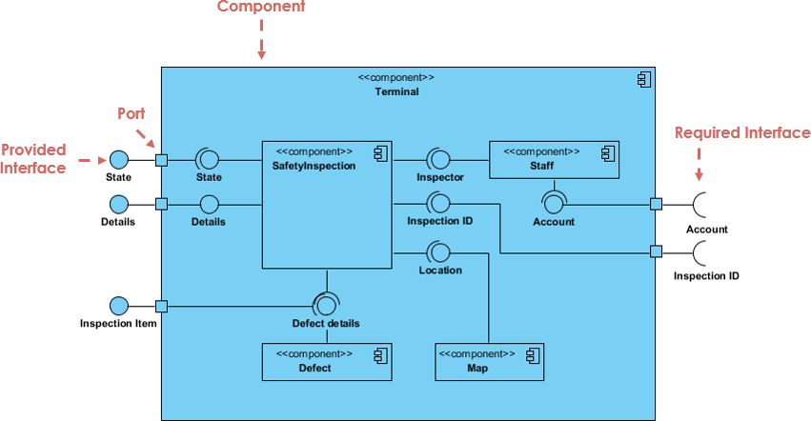
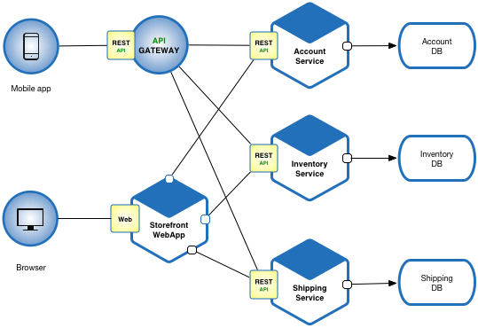
✅ Purpose
Shows high-level software components

🎯 Uses
- Microservices
- Modular systems
- System architecture

🔹 7. Deployment Diagram
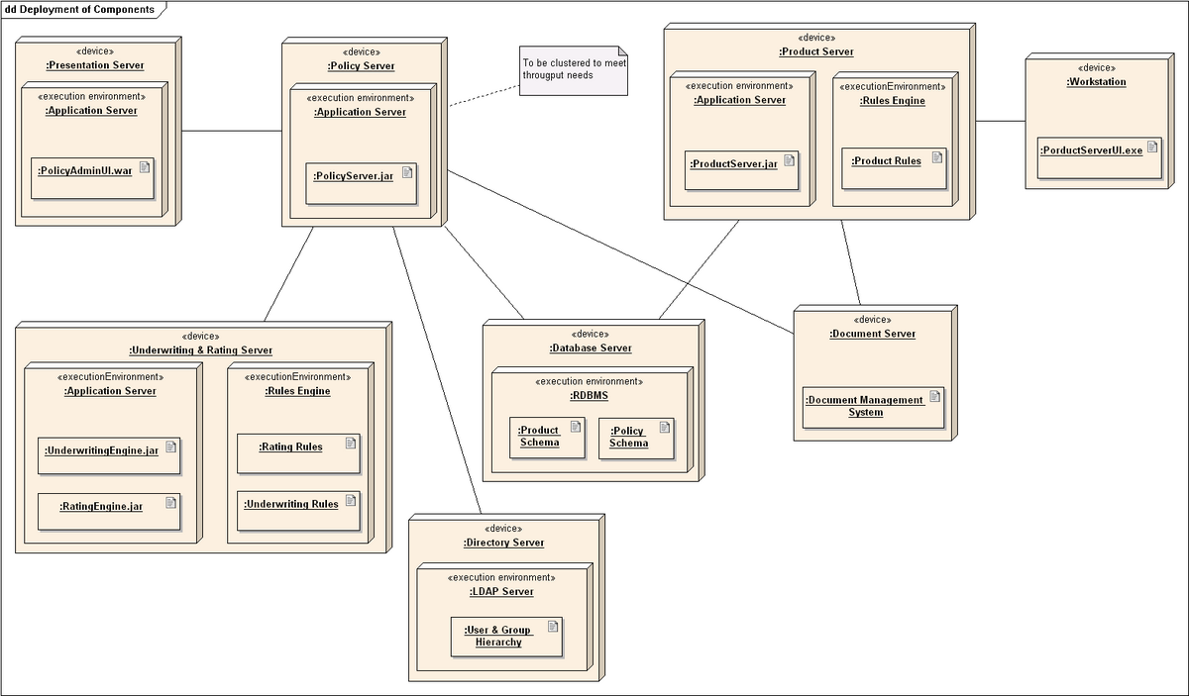
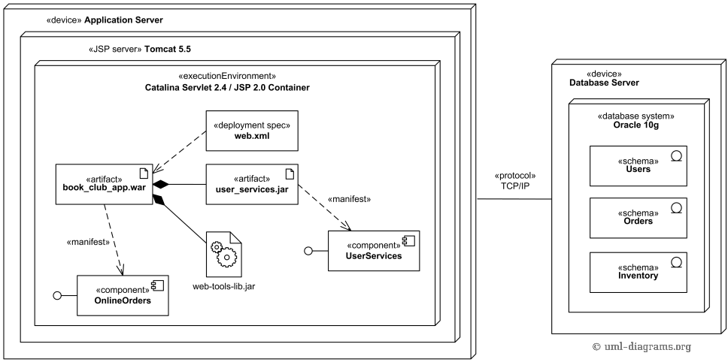
✅ Purpose
Shows physical deployment

🎯 Uses
- Cloud architecture
- DevOps planning
- Infrastructure design

🔷 UML Diagram Elements (Must-Know)

🔹 1. Class
+----------------+
| Class Name |
+----------------+
| attributes |
+----------------+
| methods |
+----------------+

🔹 2. Visibility Symbols
Symbol | Meaning
+ | Public
- | Private
# | Protected
~ | Default

🔹 3. Relationships
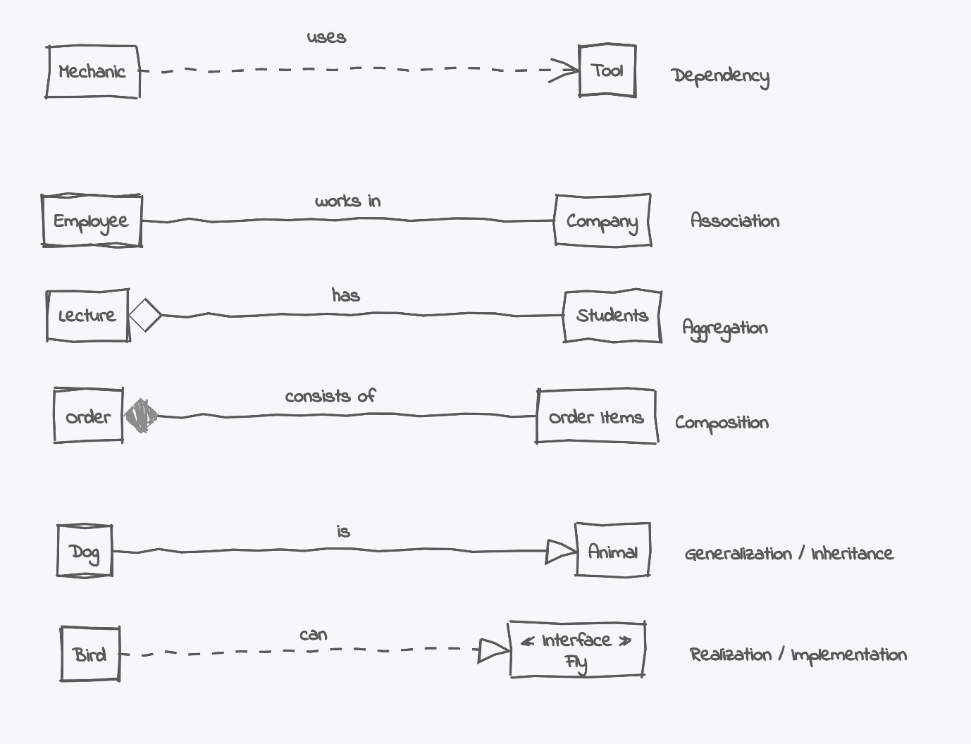
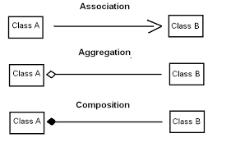
Relationship | Meaning
Association | Uses
Inheritance | IS-A
Aggregation | HAS-A (weak)
Composition | HAS-A (strong)
Dependency | Depends on

🔹 4. Actor (Use Case)
👤 Represents a user or system.

🔹 5. Use Case
⭕ Oval showing system functionality.

🔹 6. Lifeline (Sequence Diagram)
Vertical dashed line → object lifetime.

🔹 7. Messages
➡ Arrows showing method calls.

🔷 UML Diagram – Benefits Summary
Benefit | Explanation
Clarity | Visual clarity of system
Fewer Bugs | Design flaws caught early
Faster Development | Clear roadmap
Better Communication | Common language
Documentation | Long-term reference

🔷 Interview One-Line Answers (⭐ Important)
- UML → Standard visual modeling language
- Class Diagram → Structure
- Use Case Diagram → Requirements
- Sequence Diagram → Interaction flow
- Activity Diagram → Workflow
- State Diagram → Object lifecycle

